Fill in (20 points)

- Use the numbers below that corresponds to the appropriate term.
2 Midway 3 Island hopping 7 Germany 8 Relocation 9 Zoot Suits
5 Atomic Bombs 4 Philippines 1 Pearl Harbor 10 UN 6 Normandy

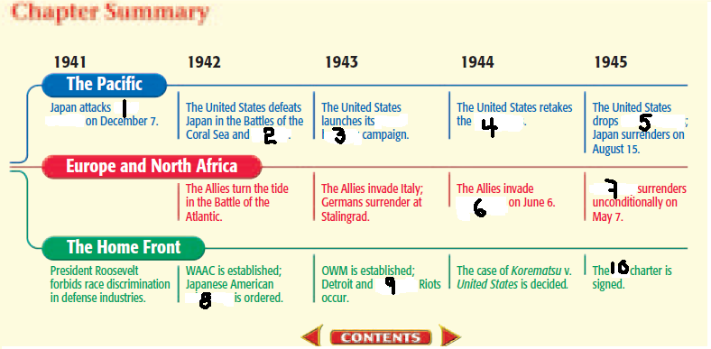

Fill in (10 points each)

- How did the American government ensure that there were enough necessities to supply the war effort? - Section 1
They used rationing, encouraged victory gardens, and controlled wages and prices.
.
- Why was the Battle of Stalingrad considered a turning point in the war? - Section 2
The Soviets defeated the Germans who lost more than 200,000 troops.

- How did the war effort change employment opportunities for women and African Americans? - Section 3
Women and African Americans had new, but temporary, job opportunities.

- What four agreements did “The Big Three” make at Tehran? - Section 4
- Russian second front against Germany
- German post war division
- Soviet assistance against Japan
- Post war international organization

- Why were the victories on Iwo Jima and Okinawa so vital to the Allies? - Section 5 - (20 points)
The United States committed its manpower and economic resources to fight WWII.
Week 5 of 10.
The 4th quiz towards your midterm.

